Start to write result into word

Coder Information

True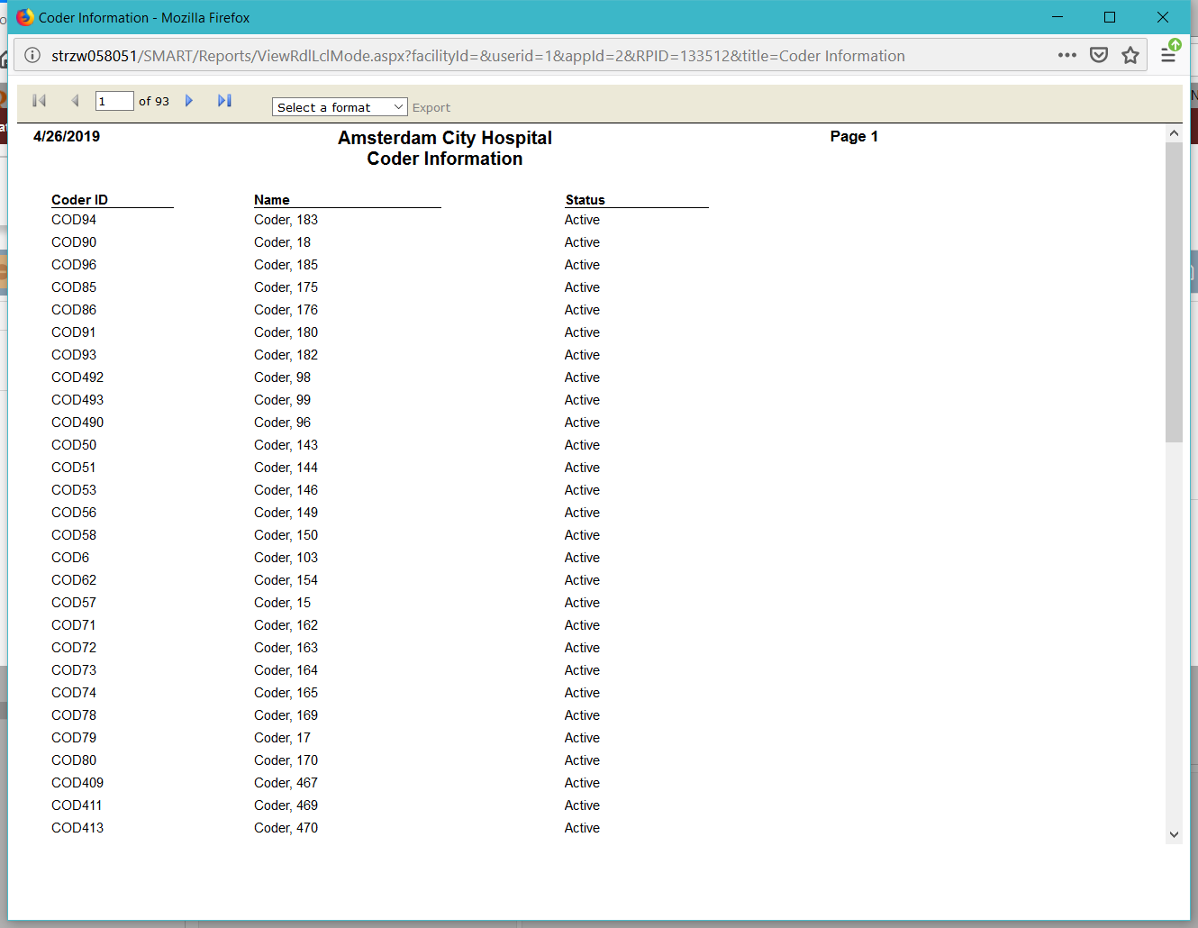

Start to write result into word

Financial Class Mapping Information

True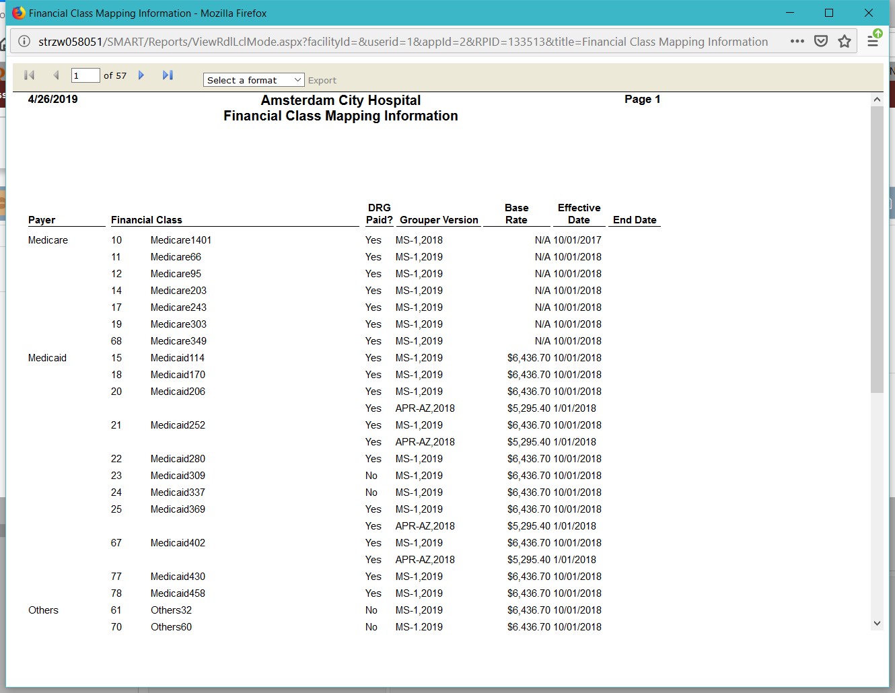

Start to write result into word

Coder Information

True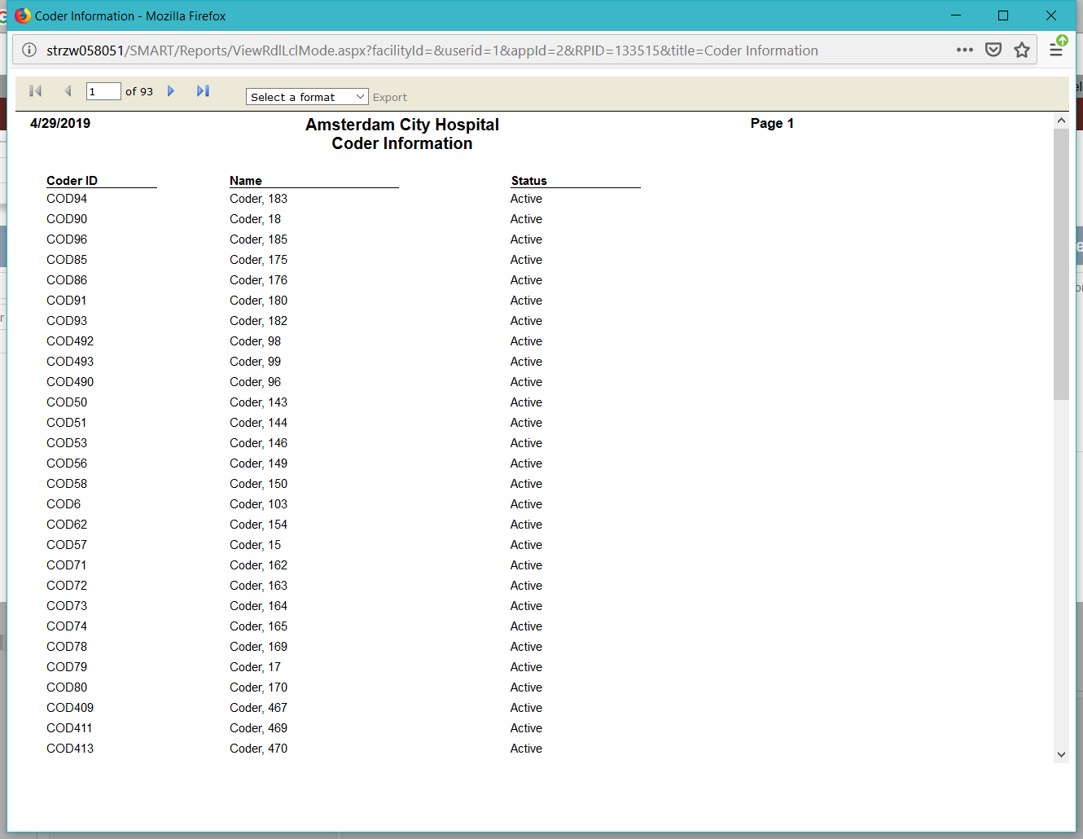

Start to write result into word

Financial Class Mapping Information

True